Lesson 3 – SAP Integration with Power Platform



Learning Objectives 2
Pre-requisites 3
Exercise 7: Import solutions and update menu system and drop downs for Power App 4
Part 1: Import Solution 4
Part 2: Create a simple Approval Flow 12
Part 3: Update Menu and Drop-Down Fields using the SAP Integration Administration app 17
Update the List of Values 17
Update the Menu 21
Exercise 8: Overview of the Procurement Template apps and flows. 25

Learning Objectives
This lab is designed for the Integration Developer that will link SAP BAPI’s and other services to Power Automate Flows that return and process SAP data. These Power Automate flows will be used by Application or Citizen Developers that will consume the SAP data coming out of the flow or potentially returning processed data back to SAP. This lab will help the Integration Developer understand the configuration and utilization of the SAP ERP connector through hands on labs. In the labs, you will create a Canvas app and Power Automate flow to retrieve PO data from SAP. You will also learn how to shape the PO data with the Power Automate flows so your developer community can seamlessly interact with the SAP data.
We will then explore the new Accelerators that are being launched as part of the Power Platform Accelerators Initiative. The Accelerators are pre-built solutions containing Power Apps and Power Automate flows. The Finance Procurement Accelerator consists of 6 Power Apps and corresponding Power Automate cloud flows that dramatically simplifies procurement for customers running SAP. SAP is a complex financial system of record, often requiring significant training and expertise to complete basic tasks like creating a new vendor. Beginning all the way upstream at Vendor Maintenance and finishing downstream with Vendor Payments, the finance accelerator will simplify each of these procurement processes to help drive down Days Payable Outstanding and recognize early vendor payment discounts by cutting down on manual vendor invoice reconciliation. SAP customers will be able to reduce the time required to complete procurement activities by up to 75% by using the Finance Procurement Accelerator.

Pre-requisites
You will need credentials to an installed and configured SAP Data Gateway with access to an SAP server and access to a Power Apps and Power Automate environment before beginning these labs. Please see your instructor for these credentials.

We have a couple of different ways to get access to the files needed for the labs.

Download the following items to a folder on your desktop from this GitHub Repository:
- SAP Procurement solution zip file
- SAP Base solution zip file
- AskSAP solution zip file
- SAP List of Values csv file
- AI Builder Training Invoices
- Vendor Invoice Template
- SAP Integration Developer Lab Guide

NOTE: To download a CSV file, click on the file name, then click on Raw. When the screen opens with the raw data, right-click and Save As to your desktop or specific folder for this workshop.

Exercise 7: Import solutions and update menu system and drop downs for Power App

Part 1: Import Solution
- Open your Power Platform Maker Portal. Using an In-Private or Incognito browser, browse to https://make.powerautomate.com using your new credentials supplied by the instructor.
- Select the correct environment. In the upper right-hand corner, click on the Environment and select the correct environment for this lab based on the information supplied by the instructor.

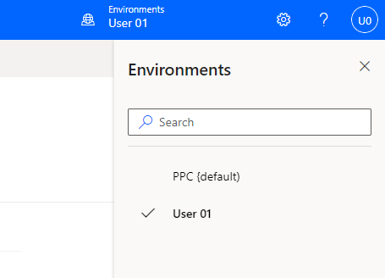

- We have ( 3 ) solutions that we will be importing. The Base template will be used to configure the menu system and the drop-down values in the Power App. The Procurement template contains the Power Apps and Power Automate flows for creating vendors, requisitions, purchase orders, goods receipts and invoices. Both of these solutions are managed solutions. We also have an unmanaged solution with some additional cloud flows for using Teams for approvals and using AI Builder to capture information from an emailed invoice to create a vendor invoice.

Select the Solutions Tab and click on Import Solution.
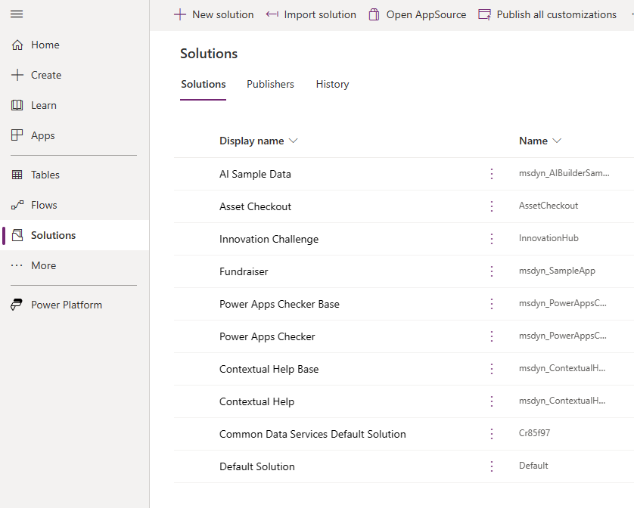

- Click on Browse and select the Base Solution titled mpa_SAPBase.zip. (You should have downloaded this file to your desktop. File is located in this GitHub Repository or in the SAP Workshop Team site for this demo tenant ) After you have selected the file, click on Next.

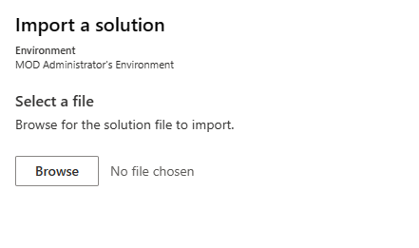
- Then hit Next
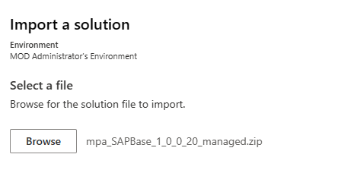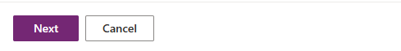
- Configure the Environment variables based on the information below and then click on Import.
SAP Language Key: EN ( CASE SENSITIVE )
SAP Client ID: 800
SAP System ID: ABA
SAP Application Server:
{"AppServerHost" : "10.0.1.203", "LogonType":"ApplicationServer", "SystemNumber": "00", "Client":"800"}
SAP Count of Rows To Read: 1000

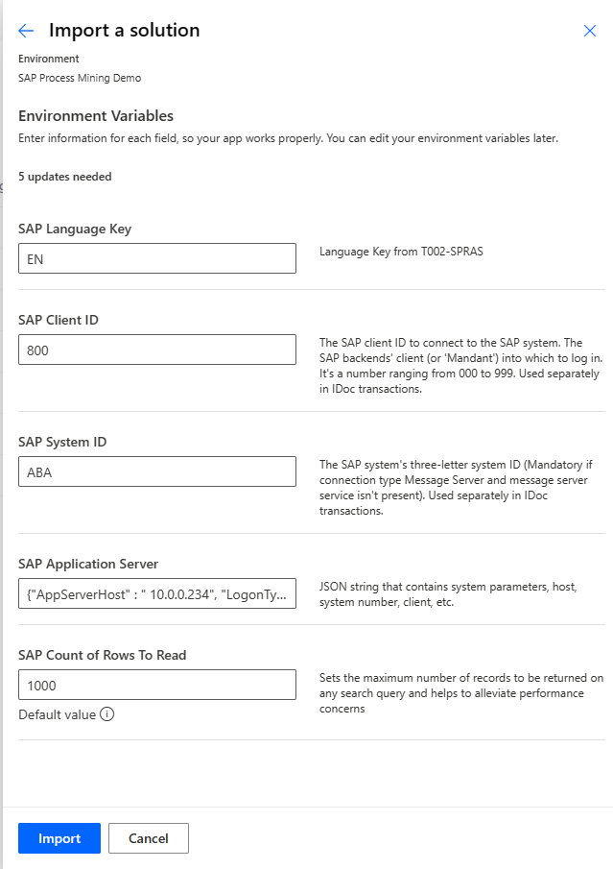

- It will take a few minutes to import the solution and you will see a message in the top ribbon that the solution is being imported.

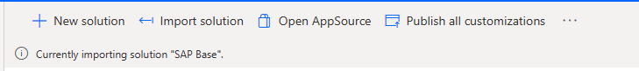

When you see the solution has successfully imported, you can move onto the next step.

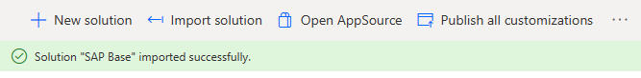

- Next, we will import the Procurement template. Click on Import Solution again in the upper ribbon.
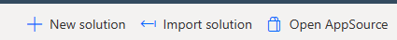

- Click on Browse and select the Procurement template titled mpa_SAPProcurement.zip. (You should have downloaded this file to your desktop. File is located in this GitHub Repository or in the SAP Workshop Team site for this demo tenant ) After you have selected the file, click on Next.

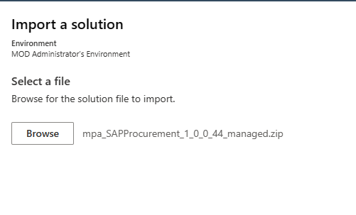
- Review the settings of the solution and then click on Next.
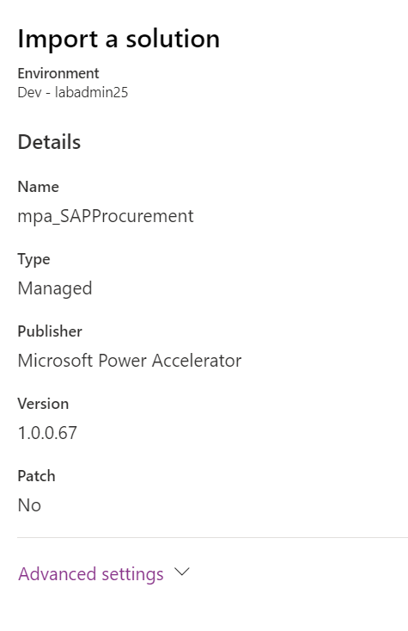
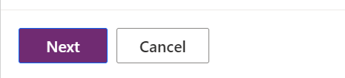

- On the next step of the import, we need to create a Connection for each Connection Reference in our solution. You will see a list of Connections that are in your solution.
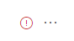
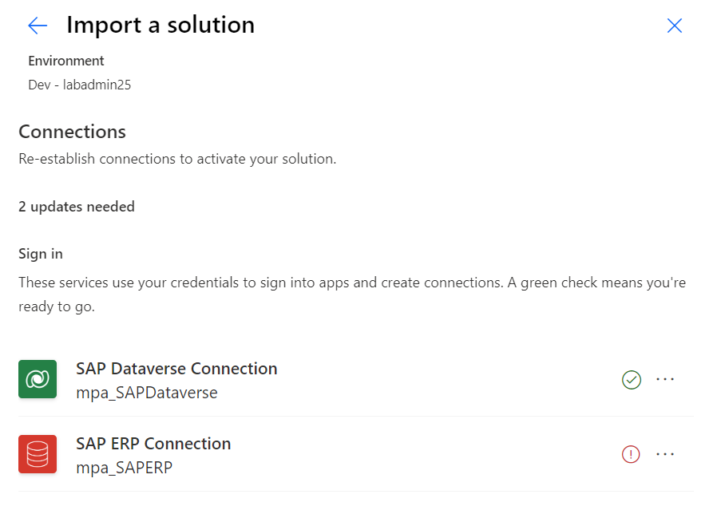

- For the SAP Dataverse Connection, click on the ellipse (…) and then select Sign In.

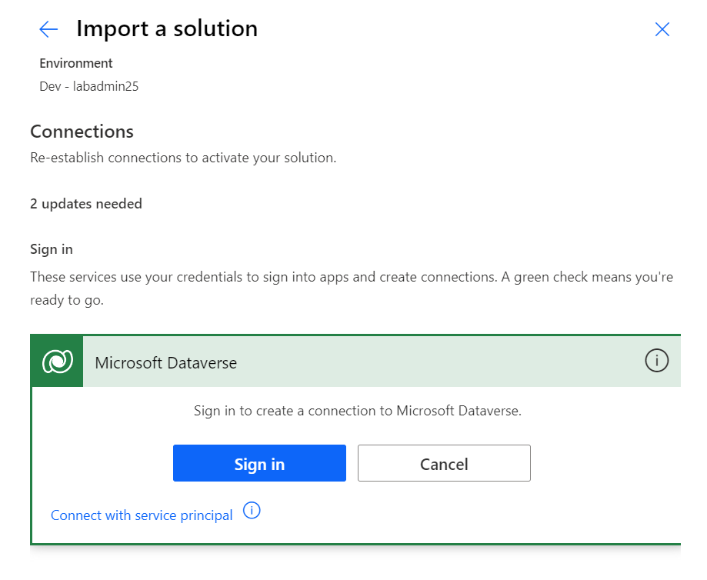

- Click on the ellipse (…) to configure the SAP ERP Connection. Click on +Add new connection.
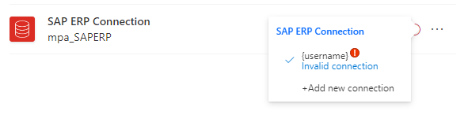
- Configure the connection with SAP Authentication as the Authentication Type and use the SAP User credentials and Data gateway provided by the instructor for the workshop. Click on Create.

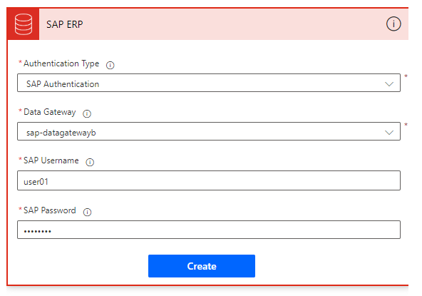

- Once we have all Connections established with green check marks, select Import button to Import Solution.

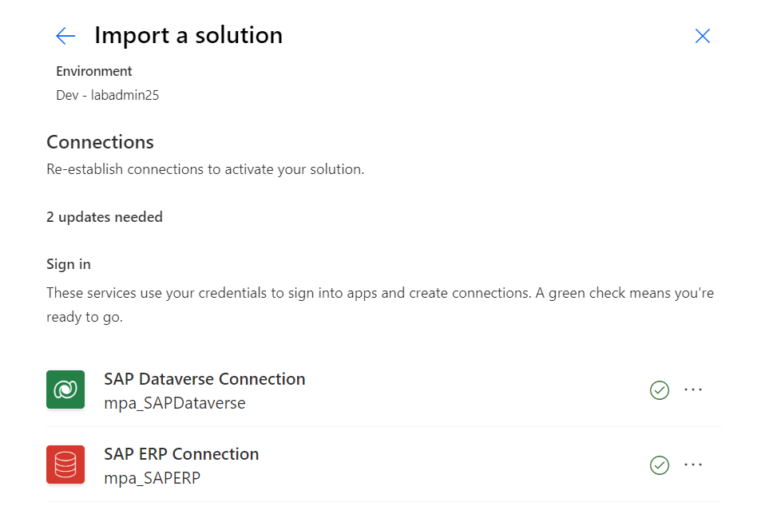
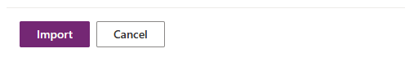

- This notification shows that Solution is importing. This will take a few minutes to complete the import. You can move onto the next step while it finishes importing.

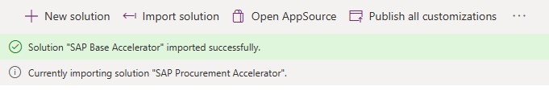

Part 2: Create a simple Approval Flow
We need to create a simple Approval flow so the Approval Table will be created in our environment to allow for the import of our Approval flows in a later exercise.
- In the left-hand menu, click on + Create and select Instant cloud flow.
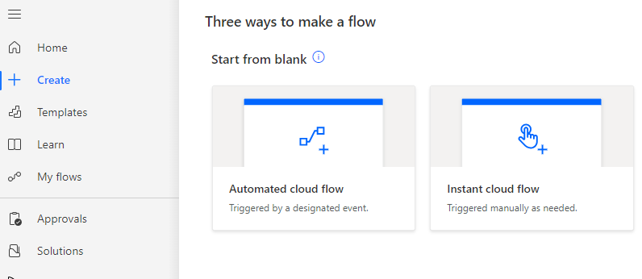

- Name the flow Test Approval Flow and select Manually trigger a flow and then click on Create.
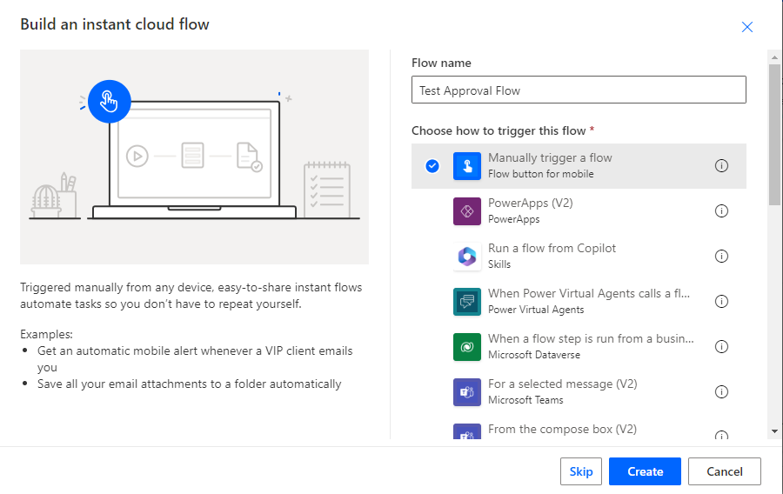

- Click on + New step.

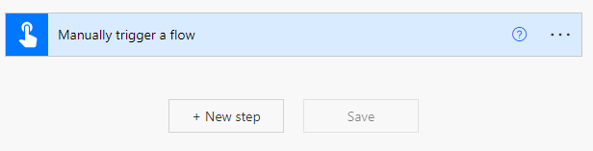

- Search for Approvals and select Create an approval.

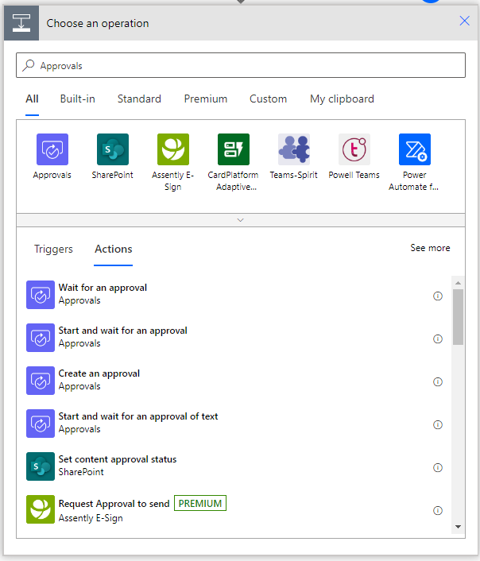

- For Approval type, select Approve/Reject – First to respond.

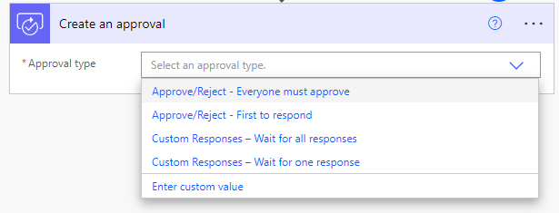

- For Title, type Test Approval and Assigned to type your lab credential email and then click on Save.

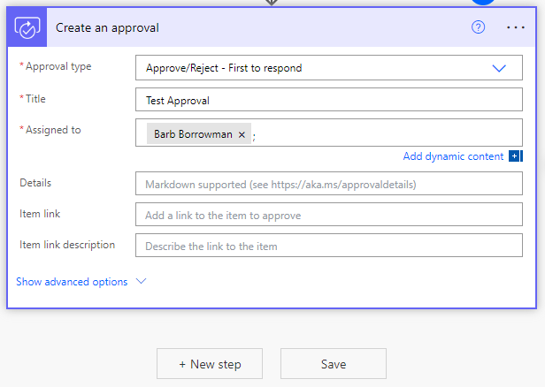

- You will get a Flow checker warning that we need to run the flow to initiate the provisioning of the Approvals table. Close the warning.
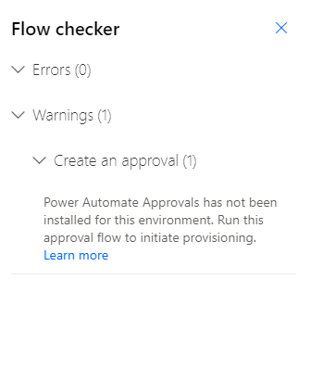

- Test the flow. Click on Test in the upper ribbon.

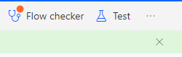
- Select Manually and then Test.

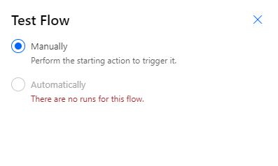
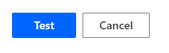
- Click on Continue then Run Flow and then Done.

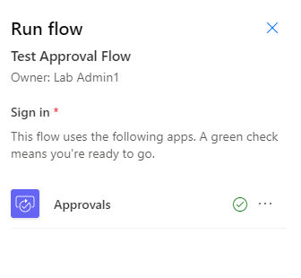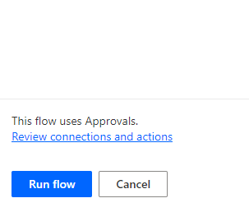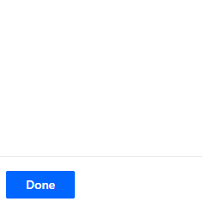
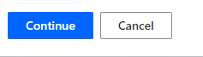

Part 3: Update Menu and Drop-Down Fields using the SAP Integration Administration app

Update the List of Values
We have a model-driven app that is part of the SAP Base Accelerator that allows you to control the menu system and drop-down values in the Power App applications. We will use this application to add menu items and drop-down values to our Power App applications. We need to update the drop-down values that will populate in the applications. We are using an export from our demo SAP system for the labs. When using these templates for your specific SAP system, please work with your SAP Administrator and/or Functional Analyst to export the necessary values from SAP and import them using this same process.

- Open the SAP Base Solution. You can either click on the solution name, or Select the solution name, then click on the ellipses (…) and select Edit.

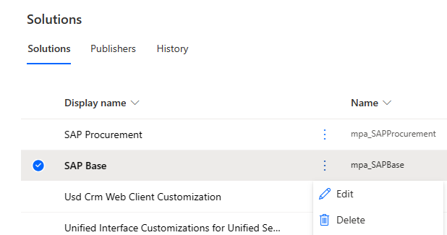

- In the left-hand Objects menu, select Apps to filter only the applications. Click on the ellipse and then select Play for the SAP Template Administrator App.

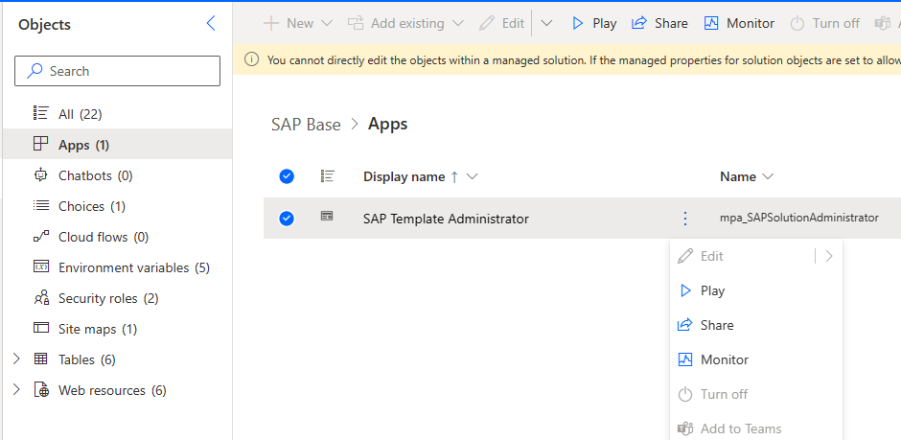

- Under Application Setup, select List of Values.
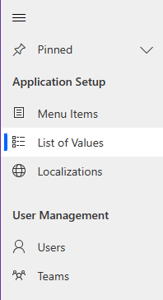
- In the upper ribbon, click on the drop down for Import from Excel and choose Import from CSV.
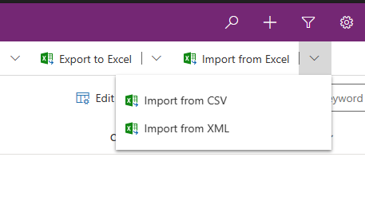
If you don’t see the command in the ribbon, you may need to click on the 3 buttons to see more options.
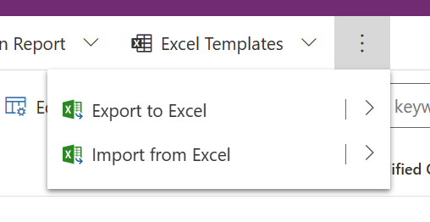
- Click on Choose File and select the SAP List of Values CSV file from our Workshop Resources and then click on Next.

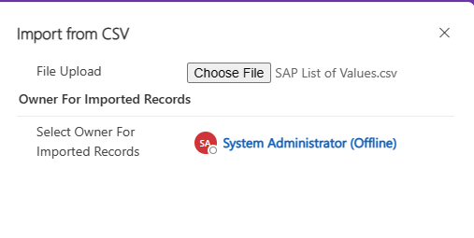
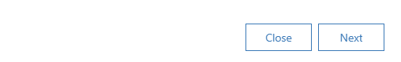
- You will see a message confirming some settings. Click on Review Mapping.

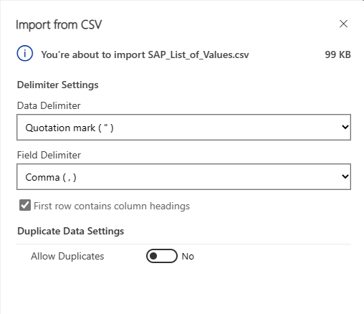
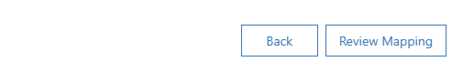

- Confirm all the mappings are correct and then click on Finish Import and then Done.
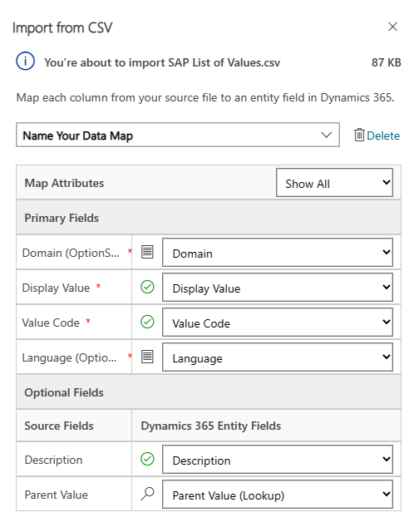
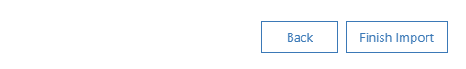
- It will take a few minutes to import. Click on Refresh in the upper ribbon and you will see data in the Active SAP Base List of Values table.

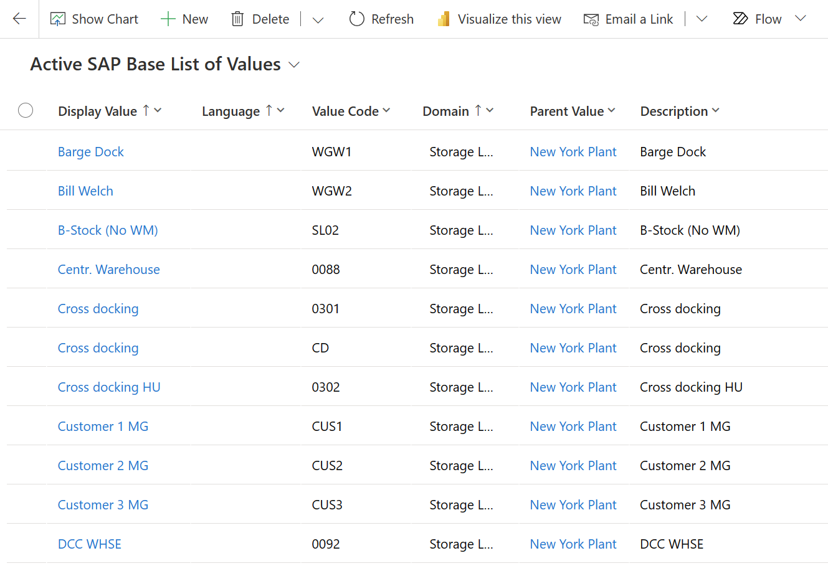

Update the Menu

- We will now create the Menu Items. In the left-hand Application Setup menu, select Menu Items.
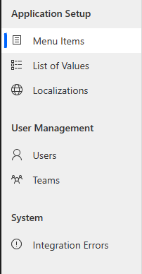

- Click on + New to create a new Menu Item.

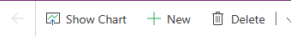

- The Procurement Template currently has ( 6 ) applications – Vendor Management, Purchase Requisitions, Purchase Orders, Goods Receipts, Vendor Invoices and Vendor Payments. We will create a menu item for all of these applications. Fill out the Vendor Management menu item with the following information:

Menu Item Name: Vendor Management
Menu Group: Purchasing
Order: 1
Capability: Vendors
Launch URL: Copy from the details page of the SAP Vendor Management App in your Procurement Integration Solution. More details on how to find this URL on the next page if needed. I find it easier to duplicate the tab and have the Procurement Solution open to copy the URL from.
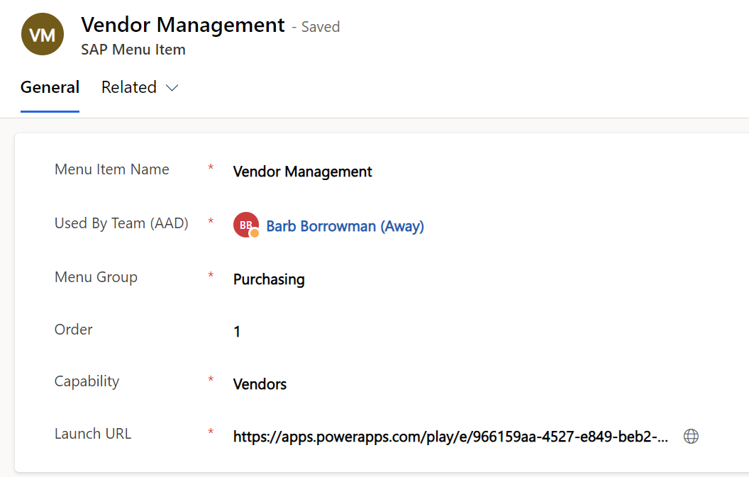

- Click on Save and Close.

Finding the application URL

To find the application URL, you will need to open the solution that the application resides in. In our case, we will open the SAP Procurement solution. In the left-hand Objects menu, filter on Apps. Click on the ellipse of the specific app and then click on Details.

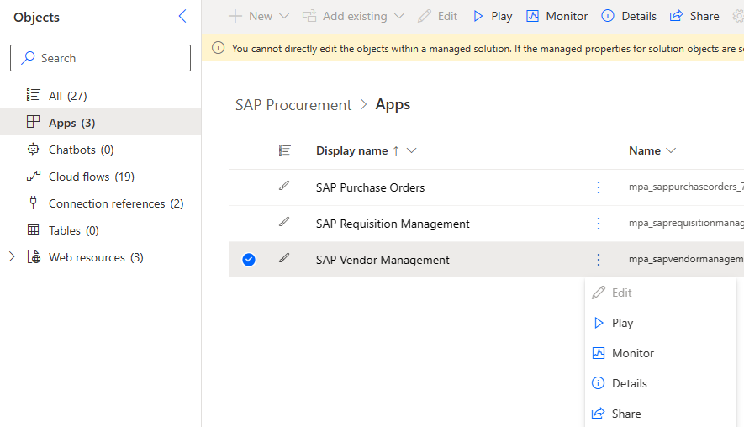

Click on the copy icon for the Web link. If the copy icon does not work, manually copy the link.
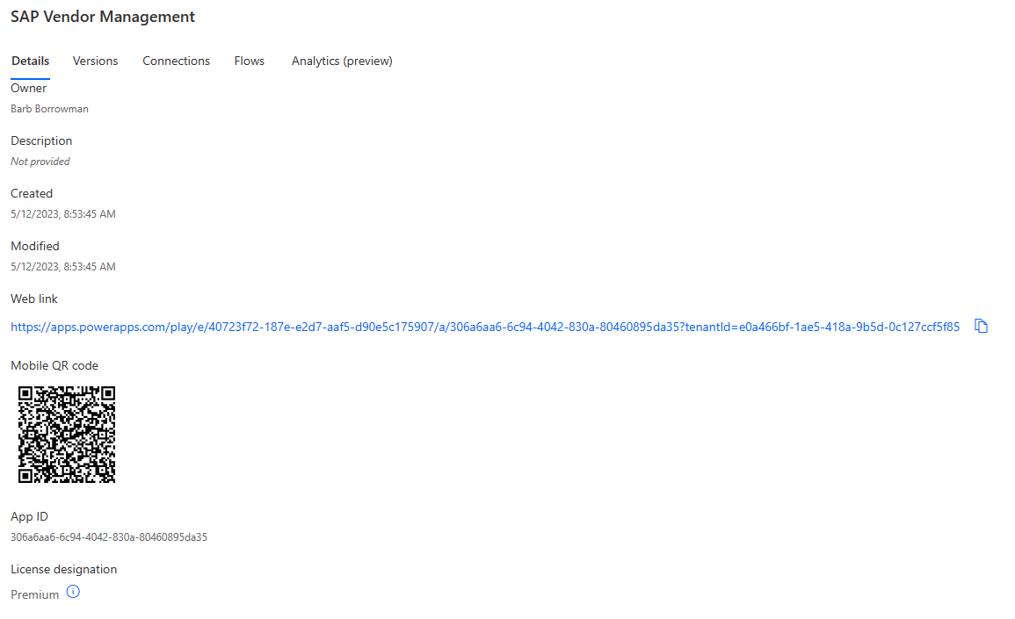

- Using the same steps, create new menu items using the table below:

Menu Item Name | Menu Group | Order | Capability | Launch URL
Requisitions | Purchasing | 2 | Requisitions | Copy from the details page of the Purchase Requisitions App in your SAP Procurement Solution.
Purchase Orders | Purchasing | 3 | Purchase Orders | Copy from the details page of the Purchase Orders App in your SAP Procurement Solution.
Goods Receipt | Purchasing | 4 | Goods Receipt | Copy from the details page of the Goods Receipt App in your SAP Procurement Solution.
Vendor Invoices | Purchasing | 5 | Vendor Invoices | Copy from the details page of the Vendor Invoices App in your SAP Procurement Solution.
Vendor Payments | Purchasing | 6 | Vendor Payments | Copy from the details page of the Vendor Payment App in your SAP Procurement Solution.

Exercise 8: Overview of the Procurement Template apps and flows.
In this exercise, we will walk through the apps and flows in the Procurement template.
- Open SAP Procurement solution. Still in an In-Private or Incognito browser, browse to make.powerautomate.com and select your correct environment from the lab credentials. Then click on Solutions.

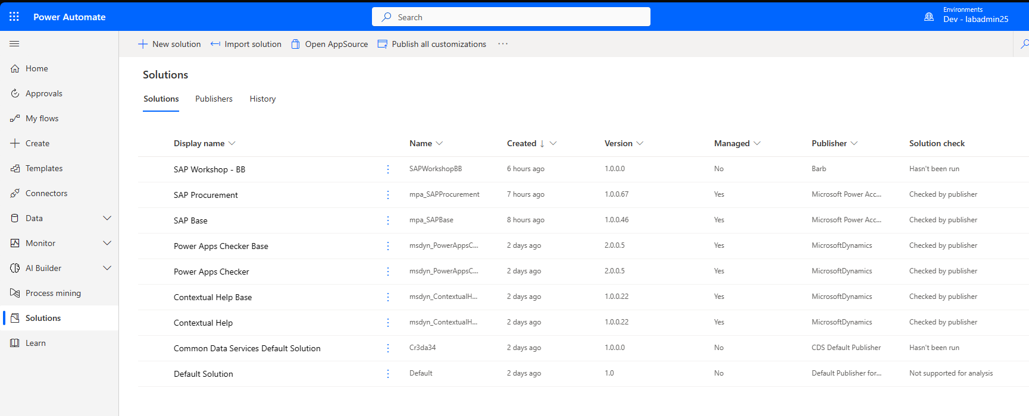

- Select the Procurement Solution then click on the ellipse (…) and select edit.
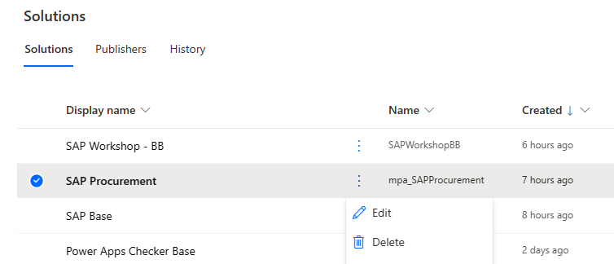
- In the left-hand menu, filter on Apps.

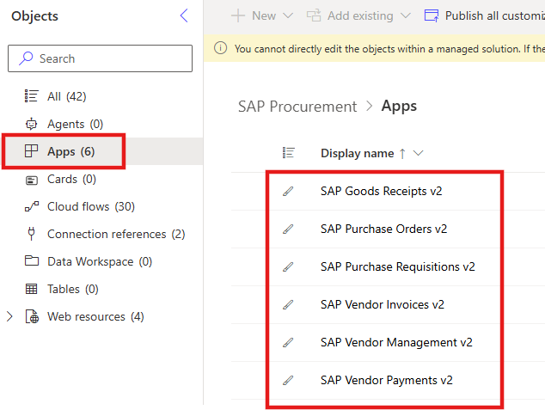
- Select Vendor Management, click on the ellipse (…) and then click on Play. Since this is a managed solution, we do not have the ability to edit the app.

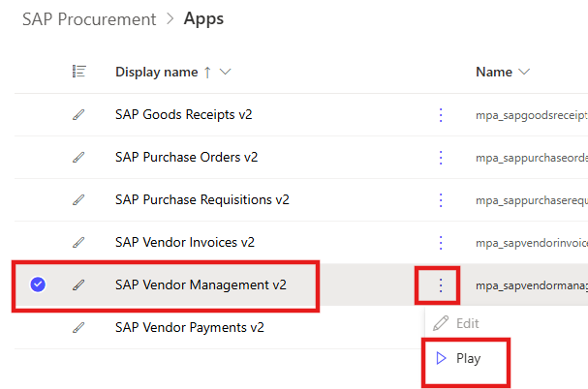

- Click on Allow for access to the connections. They should have your lab credentials.

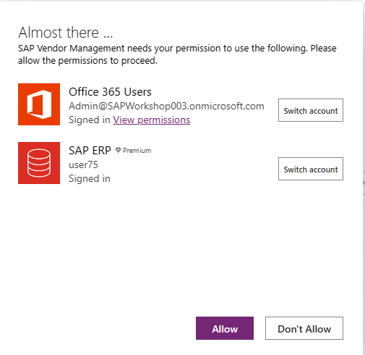

- On this screen, we can create a new vendor, select a recent vendor, search for a vendor by the vendor number or do an advanced search by clicking on the Search Vendor button.

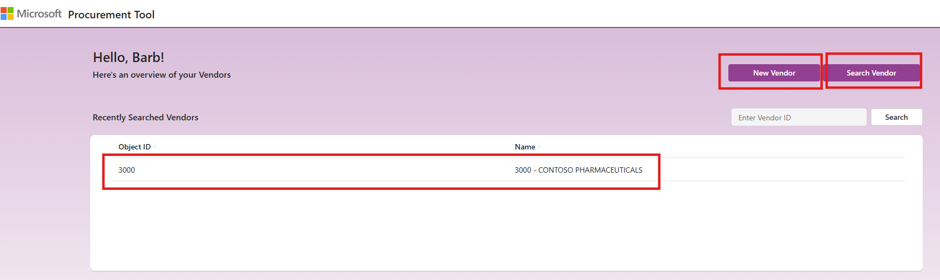

- In the upper ribbon, click on Search Vendor.
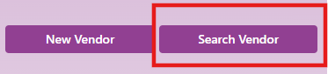
- Enter Contoso Pharmaceuticals in the Vendor Name box and click on Search. You can search by other vendor characteristics.

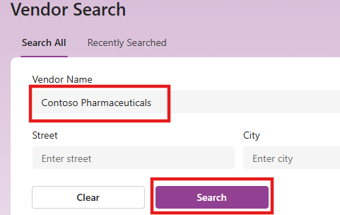

- Select the Contoso Pharmaceuticals vendor to see more details on the vendor. We have different tabs to view Vendor Details, Requisitions, Purchase Orders, Goods Receipts, Invoices and Payments for that vendor.

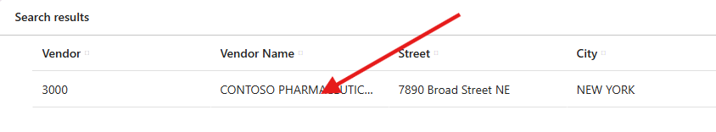
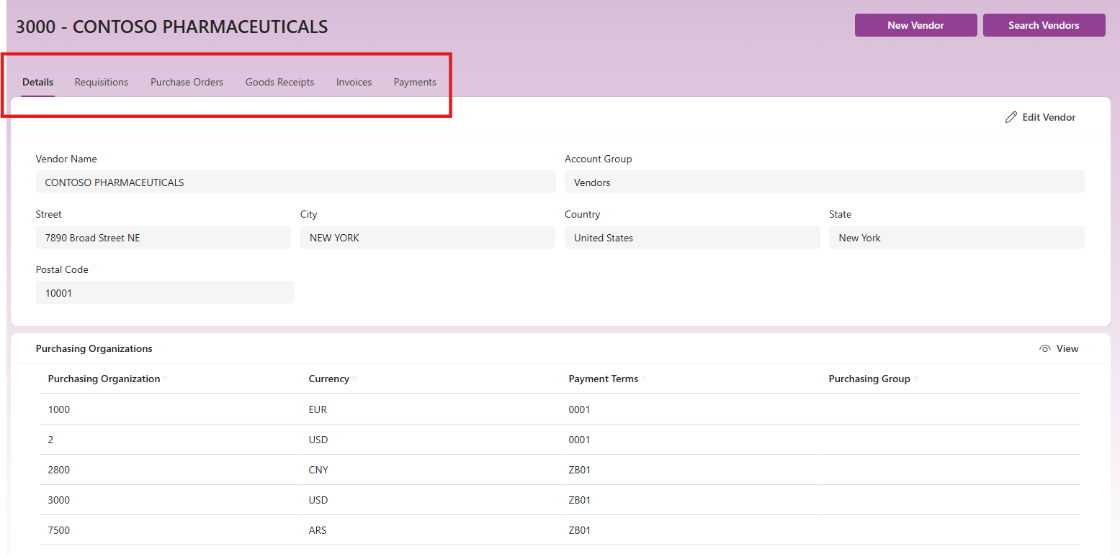

SAP Vendor Management app - Power Platform | Microsoft Learn
Vendor Management App | SAP Procurement Solution Templates on Power Platform - YouTube

- On the left-hand menu, select Purchase Requisitions. This will open that application in a new tab. Once again, you need to allow your connections the first time you open the app.

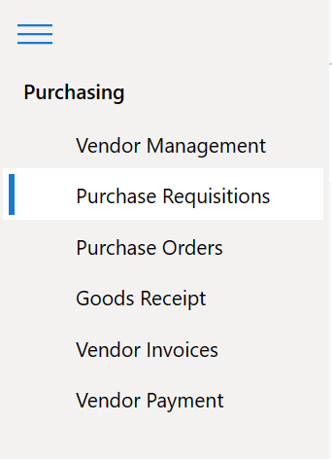

- Like Vendor Management, we can create a new requisition, view a recent requisition, search by requisition number or do an advanced search by clicking on the Search Purchase Requisitions button.

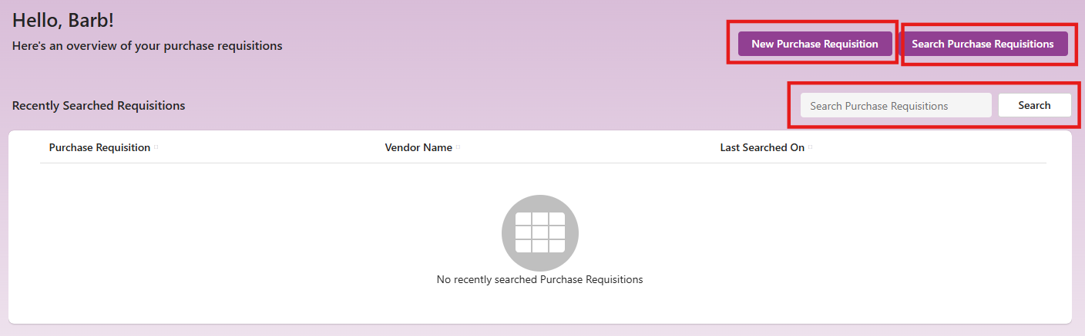

- Create a new requisition. Click on the New Purchase Requisition button. Create the requisition with the following details in the header:
Vendor Number: 3000 ( Contoso Pharmaceuticals ) – Click on the Search button to bring back the data from SAP.
Purchasing Organization: Best Run USA
Purchasing Group: PG US
Location: New York Plant
Currency: United States Dollar USD

Then click Next.

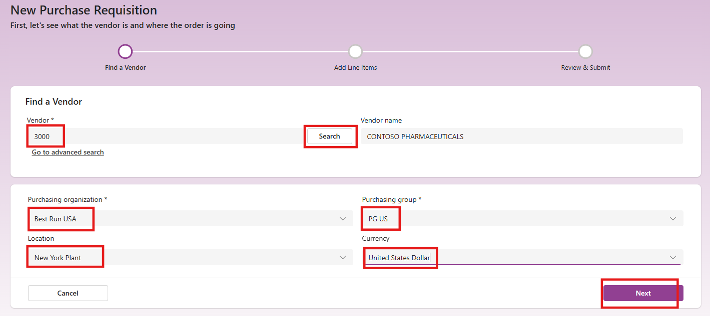

- Add product line items. Enter the material number 938 in the Items section to add items to our requisition.

- Add product line items. In the Material field, type in 938 and click on Search.
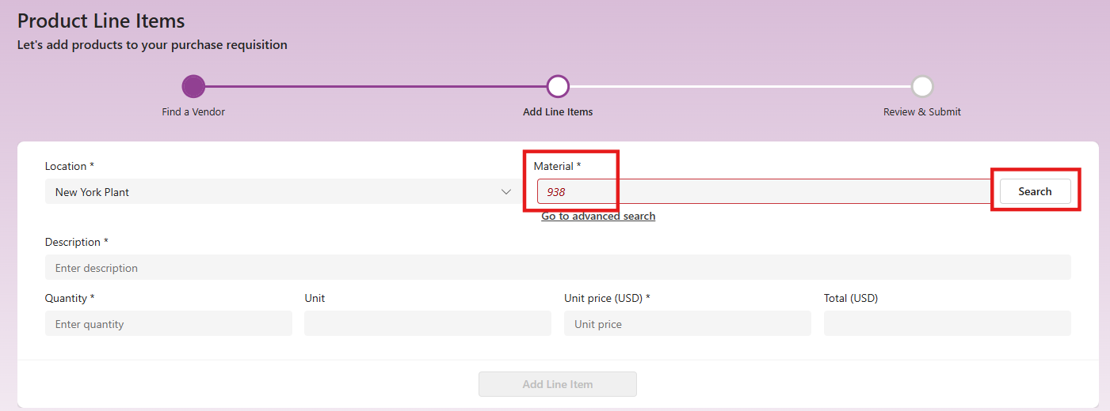
- Change the description to be 25” Monitor, enter 1 for Qty and 250.00 for the unit price. Click on Add Line Item box.

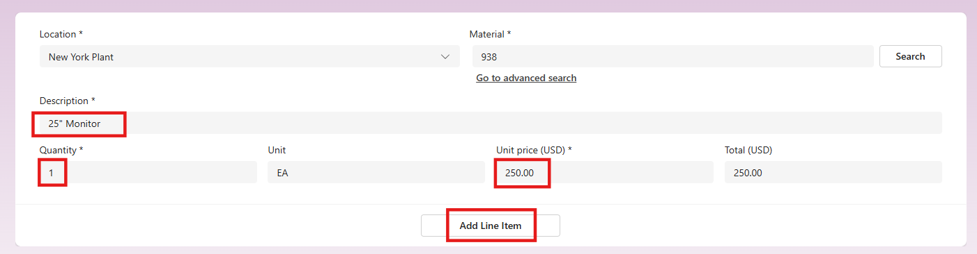
- On the bottom of the screen, click on Next.
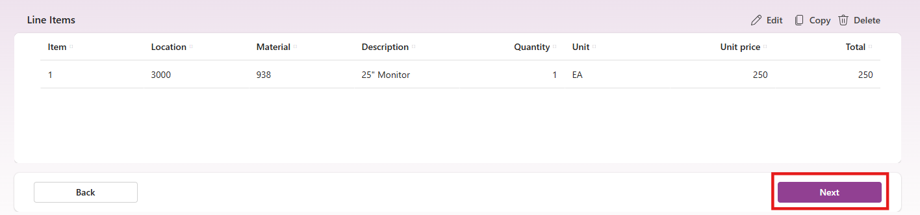
- Review and submit the requisition. Click Submit.
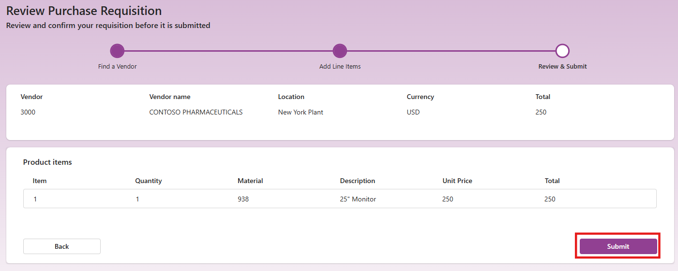

- Once the requisition is created, we will receive a notification with the requisition number and have the ability to view it. Click View Purchase Requisition.
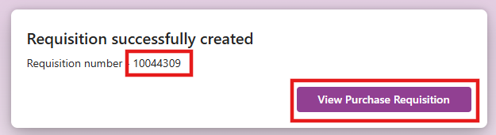
- Once the requisition is created, we now have the option to convert it to a purchase order. Click on the Convert to purchase order button.
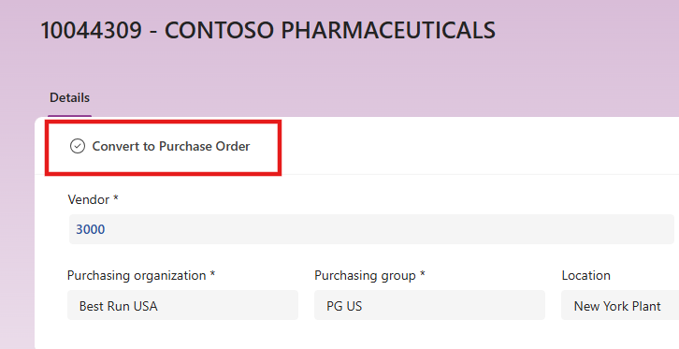

- Once the requisition has been converted to a purchase order, we will receive a message at the top of the screen with the PO number.

- You can refresh the app and you will see the PO number in the items field. Write down the PO number as we will need to reference it in a few steps.
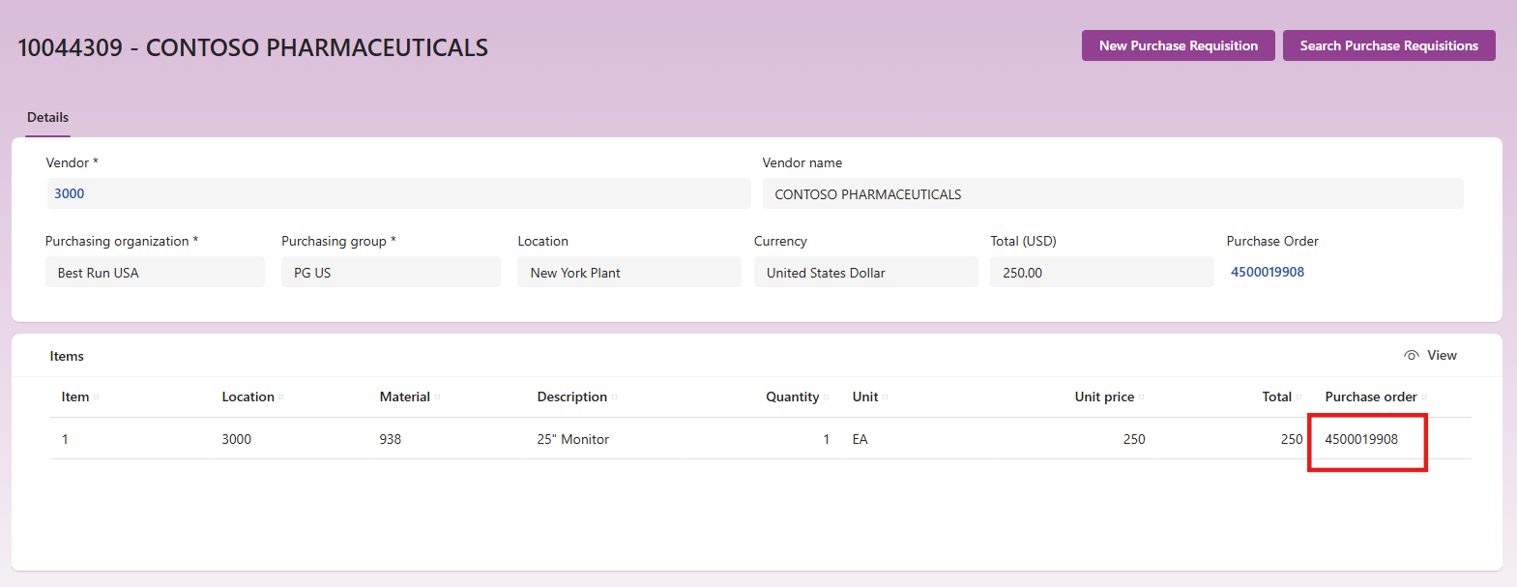
SAP Requisition Management app - Power Platform | Microsoft Learn
Requisition Management App | SAP Procurement Solution Templates on Power Platform - YouTube

- On the left-hand menu, select Purchase Orders. This will open that application in a new tab. Once again, you need to allow your connections the first time you open the app.

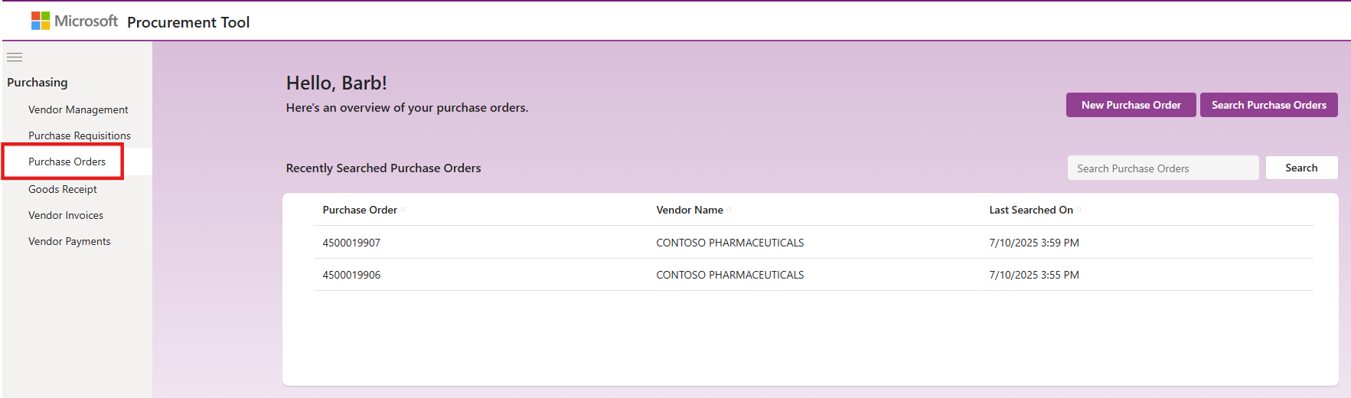

- Search for the purchase order you just created. Type your PO number in the search field and click Search.
You can find the PO number in the Purchase Requisition app tab.
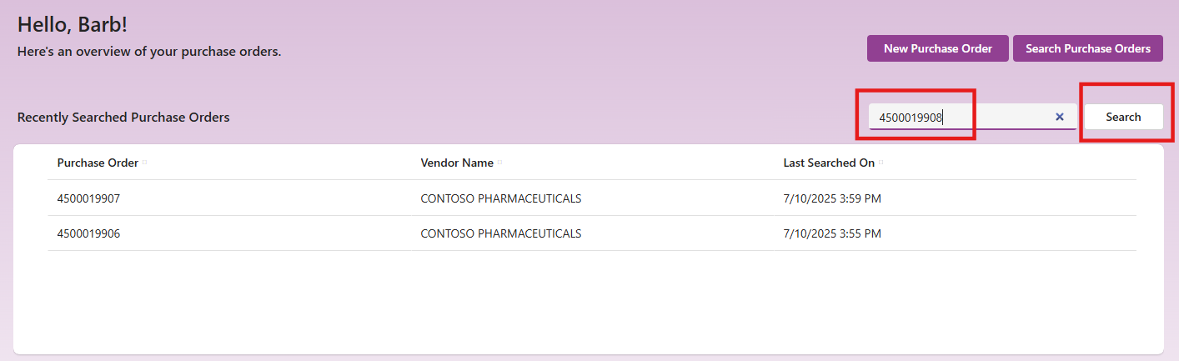

- Approve the Purchase Order. We see that we now have the button to Approve the purchase order. Click on Approve.
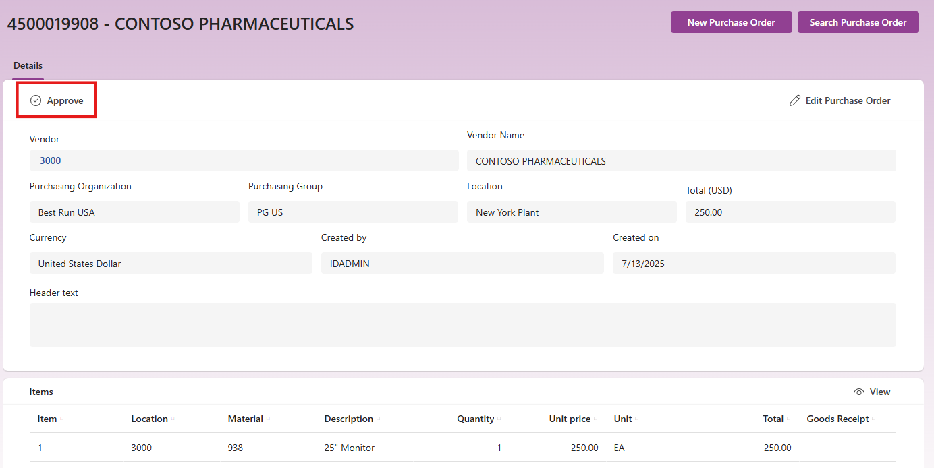

- Once the PO has been approved, we see that the Approved By field has been added and updated to reflect our SAP user ID.
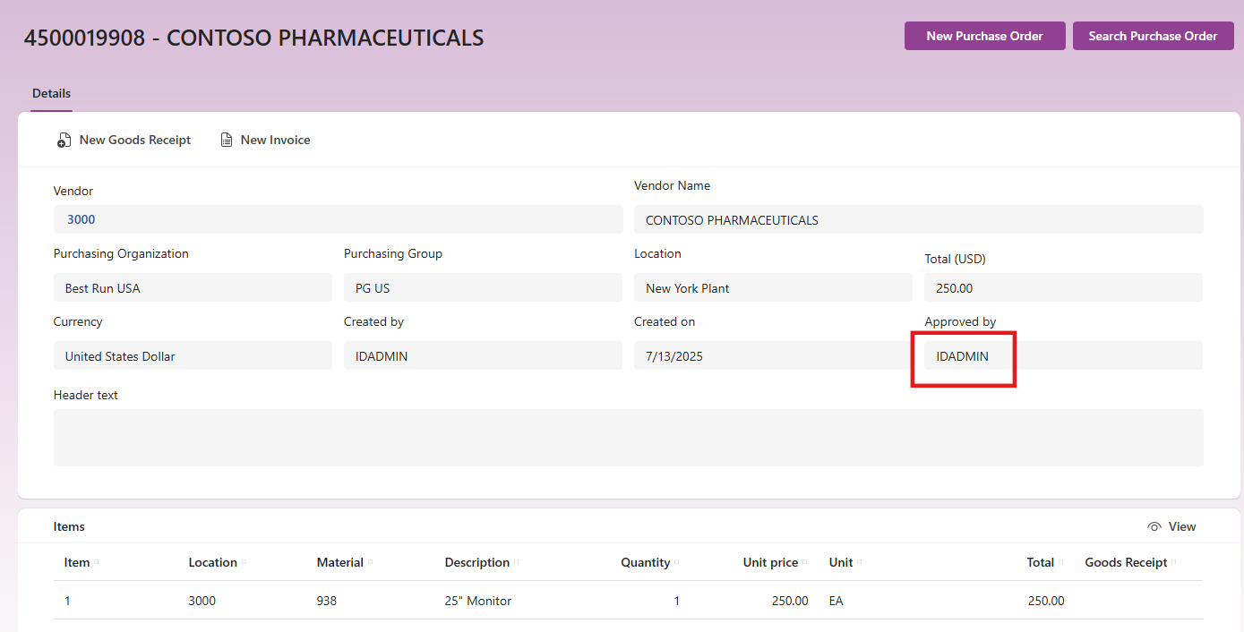
SAP Purchase Order Management app - Power Platform | Microsoft Learn
Purchase Orders Management App | SAP Procurement Solution Templates on Power Platform - YouTube
- Our next step in the process would be to receive the product. Click on New Goods Receipt in the upper ribbon. This is a new button that appears when the PO has been approved. This will open the Goods Receipt App and once again, you need to allow your connections the first time you open the app.

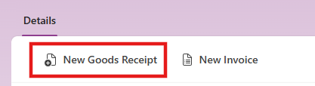

- Create a new Goods Receipt. This app has pulled up our purchase order. Click Next to update the quantity of items received.
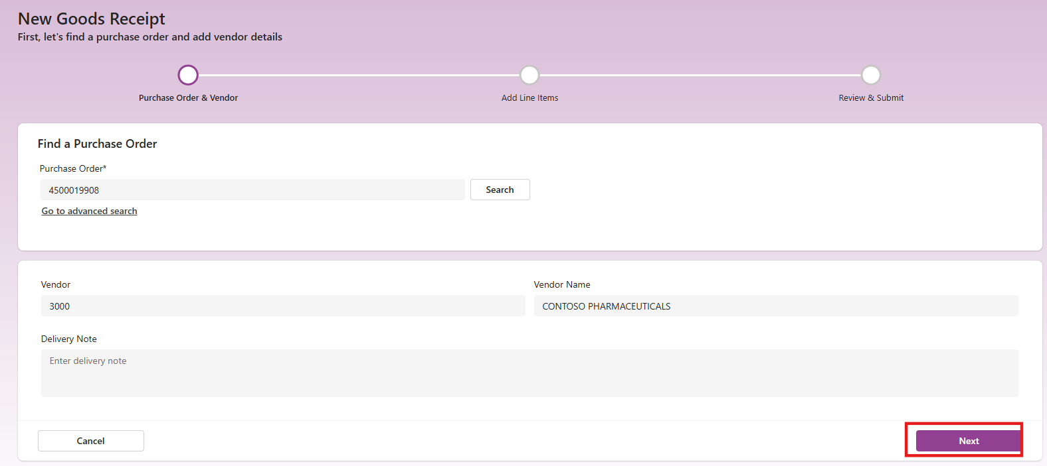
- We can select which line item we are going to work with then click Edit to select the Storage location and Qty Received.

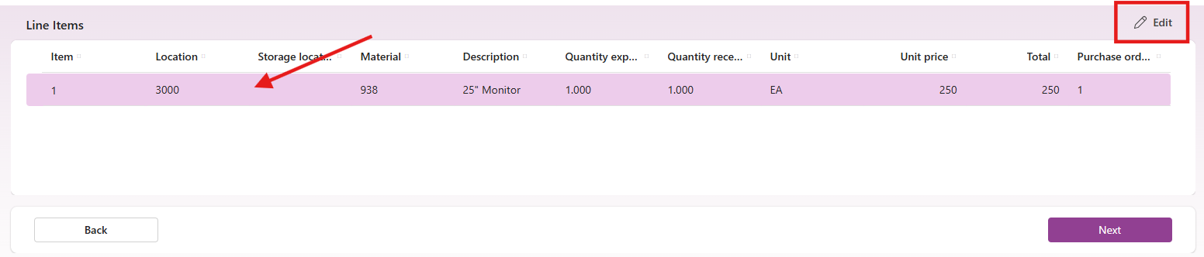

- Click on the drop down for Storage Location and select Warehouse 0001 and keep Quantity received at 1. Click on Update Line Item.

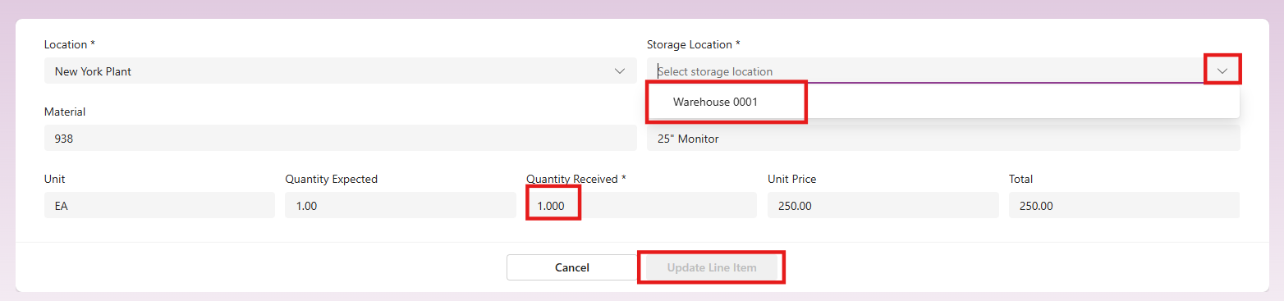
- Click Next on the bottom of the screen when you are done receiving in all your line items.
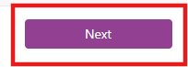

- Review and Submit. Confirm everything is correct and click Submit.

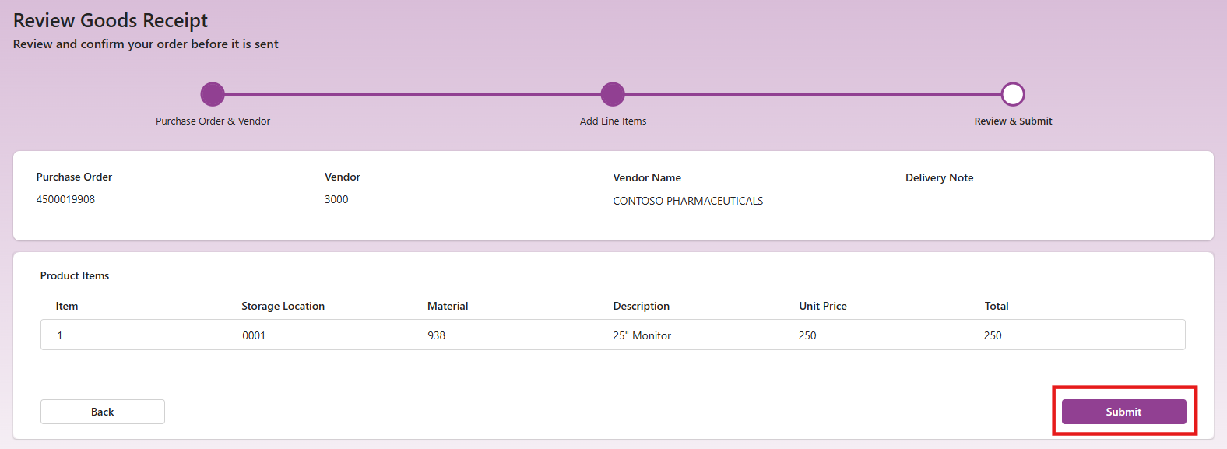

You will see a message with the Goods Receipt number.

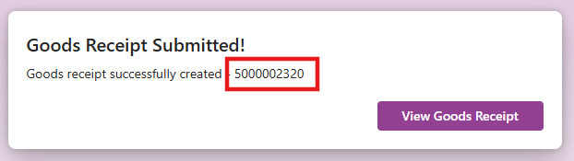

SAP Goods Receipt Management app - Power Platform | Microsoft Learn

- The next step in the process would be to create the vendor invoice. The Vendor Invoice app allows you to do several functions in SAP quicker and easier than using SAP GUI. You can view a recent vendor invoice, approve a vendor invoice for payment, and create an invoice against an existing purchase order. Click on the Vendor Invoices app in the left-hand menu. You can also click on Create New Vendor Invoice in the Purchase Order app which will preload the Purchase Order we just created. Click on New Vendor Invoice. 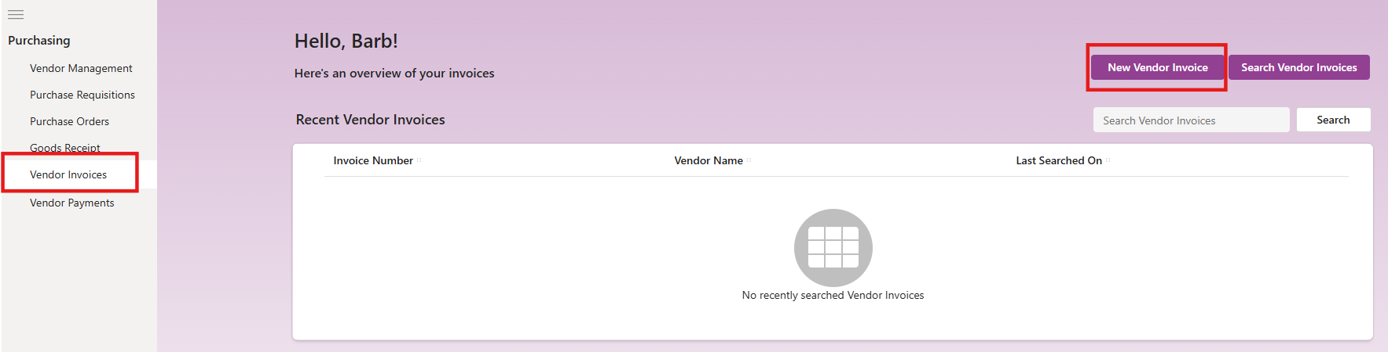

- Enter the Purchase Order you had created earlier and click Search.
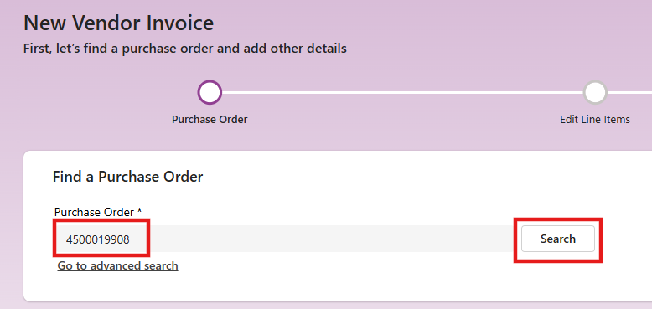

- This will collect the information on our purchase order. For Document Type, click on the drop down and select Gross Invoice Receipt. For Payment Method, click on the drop down and select Check. Click Next.
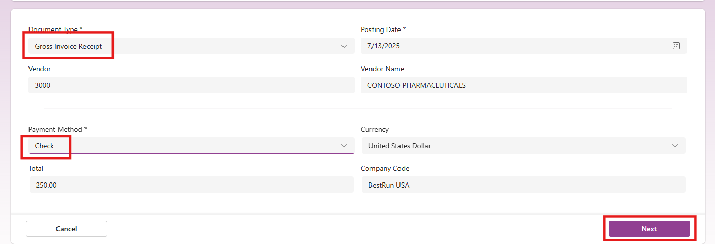
- We will now see all the line item information and can edit if needed. Click Next.
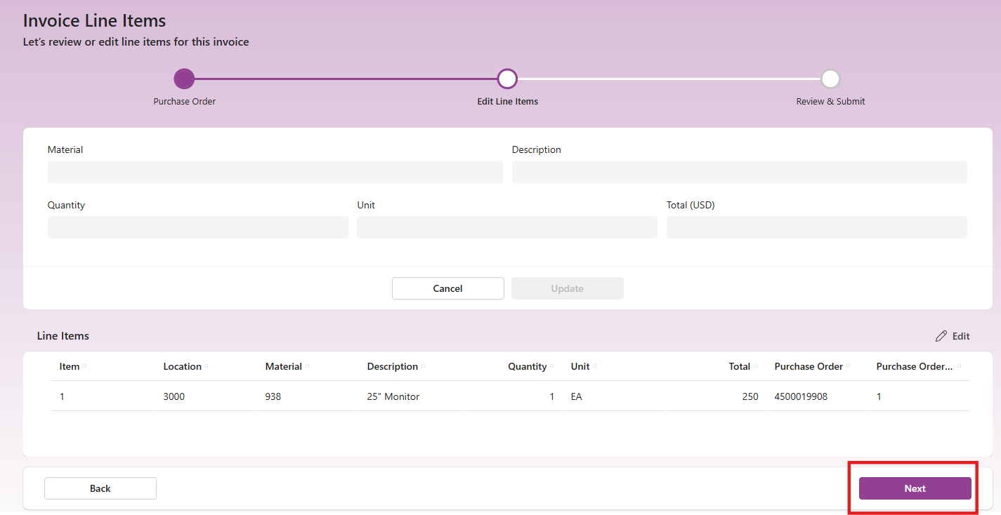
- We can now submit the invoice. Click the Submit button.

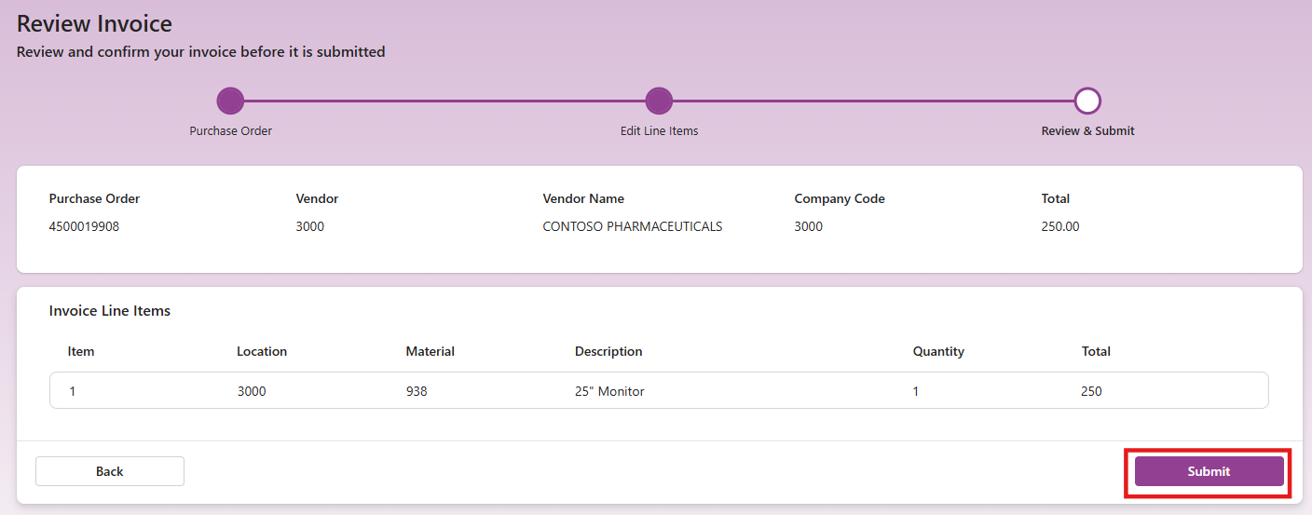
- You will get a confirmation and the invoice number. Click View Invoice.
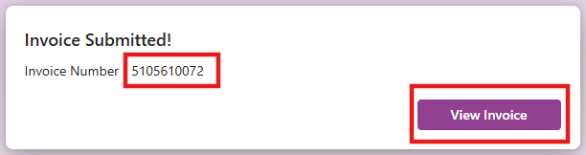
- You will see the details on the invoice with a status of Parked. We have a new button to approve the invoice. Click Approve.
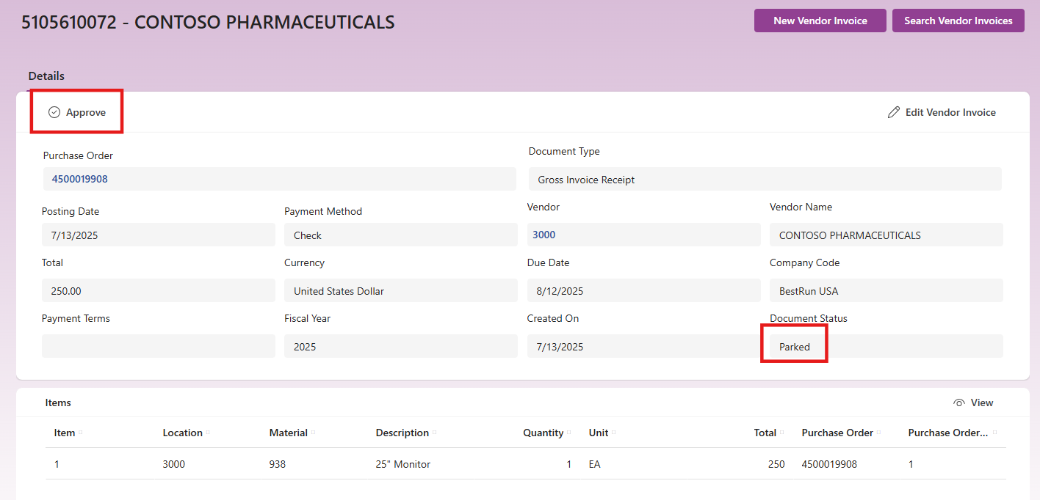

- We now see the status of the invoice is Posted.

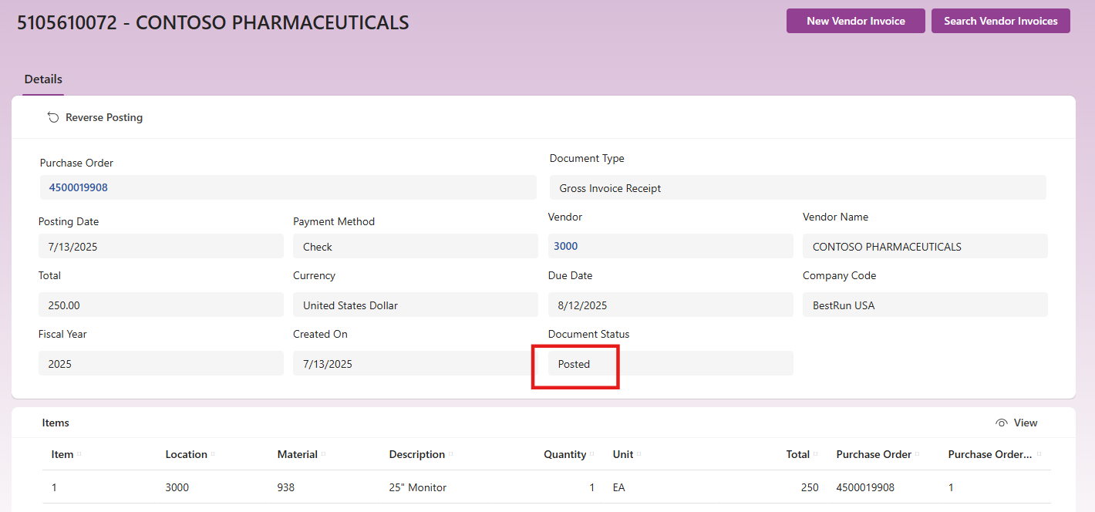

SAP Vendor Invoice Management app - Power Platform | Microsoft Learn

- The Vendor Payments app is read-only and allows you to search for and view a vendor payment quickly and easily. Click on Search Payments.
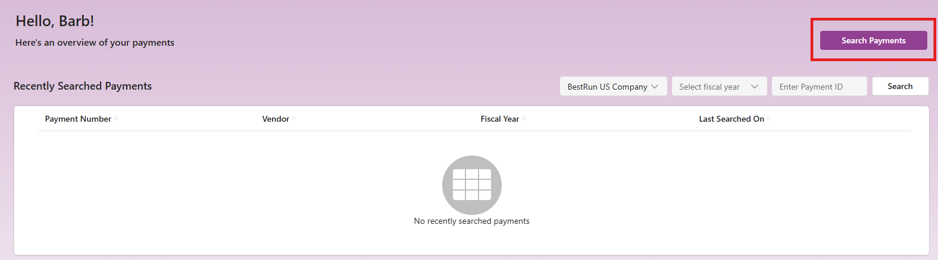
- Enter 3000 for the vendor number and click Search. You will see a list of the payments for Contoso Pharmaceuticals.

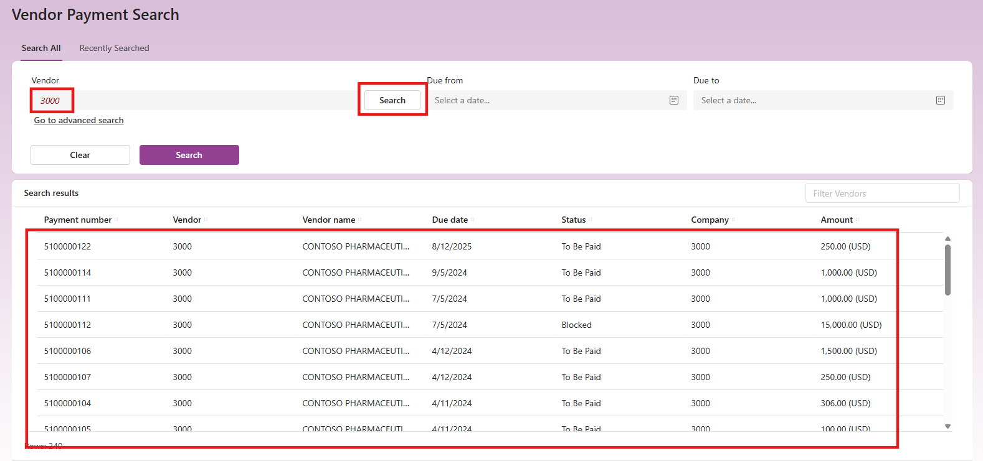

SAP Vendor Payment management app - Power Platform | Microsoft Learn

